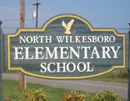
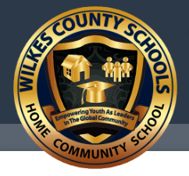
Wilkes County, NC will be hosting the
North Carolina Singapore Math Summit
Tuesday, June 26, 2018
at the Wilkes County Board of Education
8:30am-3:30pm

Please visit our weebly at http://ncsingaporemathsummit.weebly.com/
on May 26, 2018 to register for the sessions below:

Opening Session begins in the Stone Center at 8:30am

Session 1: 9:00-10:00am
- Fractions the Singapore Way, Grades 3-5th grade, Kim Bell
- Solving Two Step Word Problems using Singapore Strategies, 2nd-5th, Taggart/Teague
- Place Value: Working with numbers 11-19, K-2, Roberts/Campbell/Porter
- Using the CPA Approach in Singapore Mathematics, K-5th, Faw/Gilley

Session 2: 10:10-11:10am
- Fractions the Singapore Way Grades 3-5th continued pt 2, 3rd-5th grade, Kim Bell
- Number Bonds and Addition for K-1st, Roberts/Campbell/Porter
- How to use Math in Focus to Teach Singapore Mathematics, K-5th, Lassiter/West-Dula
- Using the CPA Approach in Singapore Mathematics, K-5th, Faw/Gilley

Session 3: 12:15-1:15pm
- New Coach to Singapore Mathematics, Byers
- Using Math Journals in grades, 2nd-5th, Lassiter/West-Dula
- Model Drawing Foundations, grades K-2, Faw/Gilley
- Solving Two Step Word Problems using Singapore Strategies, 2nd-5th, Taggart/Teague

Session 4: 1:20-2:20pm
- K-2nd Updates and Strategies from Jacksonville Conference, Byers/Taggart
- Being a new teacher to Singapore Mathematics, Lassiter/West-Dula/Kinder
- Model Drawing Foundations, grades 3rd-5th, Faw/Gilley
- Subtracting and Decomposing Numbers K-1st, Roberts/Campbell/Porter

Session 5: 2:30-3:30pm
- 3-5th Updates and Strategies from Jacksonville Conference Byers/Faw/Kinder
- Online Games and Manipulatives using Think Central, K-5th, Taggart/Teague
- Subtracting and Decomposing Numbers, K-1st, Roberts/Campbell/Porter
- Using Math Journals in grades, 2nd-5th, Lassiter/West-Dula

